Internet

Short note

Ashutosh: Shortnote on internet

2017

Internet

Internet is defined as an Information super Highway, to access information over the web. However, It can be defined in many ways as follows:

* Internet is a world-wide global system of interconnected computer networks.
* Internet uses the standard Internet Protocol (TCP/IP).
* Every computer in internet is identified by a unique IP address.
* IP Address is a unique set of numbers (such as 110.22.33.114) which identifies a computer location.
* A special computer DNS (Domain Name Server) is used to give name to the IP Address so that user can locate a computer by a name.
* For example, a DNS server will resolve a name **http://www.tutorialspoint.com** to a particular IP address to uniquely identify the computer on which this website is hosted.
* Internet is accessible to every user all over the world.

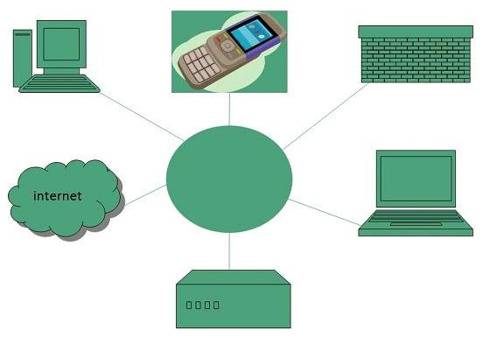

Evolution

The concept of Internet was originated in 1969 and has undergone several technological & Infrastructural changes as discussed below:

* The origin of Internet devised from the concept of **Advanced Research Project Agency Network (ARPANET).**
* **ARPANET** was developed by United States Department of Defence.
* Basic purpose of ARPANET was to provide communication among the various bodies of government.
* Initially, there were only four nodes, formally called **Hosts.**
* In 1972, the **ARPANET** spread over the globe with 23 nodes located at different countries and thus became known as **Internet.**
* By the time, with invention of new technologies such as TCP/IP protocols, DNS, WWW, browsers, scripting languages etc. Internet provided a medium to publish and access information over the web.

Advantages

Internet covers almost every aspect of life, one can think of. Here, we will discuss some of the advantages of Internet:

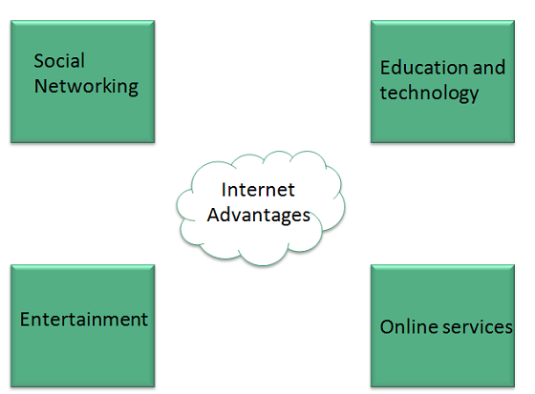

* Internet allows us to communicate with the people sitting at remote locations. There are various apps available on the wed that uses Internet as a medium for communication. One can find various social networking sites such as:
  + Facebook
  + Twitter
  + Yahoo
  + Google+
  + Flickr
  + Orkut
* One can surf for any kind of information over the internet. Information regarding various topics such as Technology, Health & Science, Social Studies, Geographical Information, Information Technology, Products etc. can be surfed with help of a search engine.
* Apart from communication and source of information, internet also serves a medium for entertainment. Following are the various modes for entertainment over internet.
  + Online Television
  + Online Games
  + Songs
  + Videos
  + Social Networking Apps
* Internet allows us to use many services like:
  + Internet Banking
  + Matrimonial Services
  + Online Shopping
  + Online Ticket Booking
  + Online Bill Payment
  + Data Sharing
  + E-mail
* Internet provides concept of **electronic commerce**, that allows the business deals to be conducted on electronic systems

Disadvantages

However, Internet has proved to be a powerful source of information in almost every field, yet there exist many disadvantages discussed below:

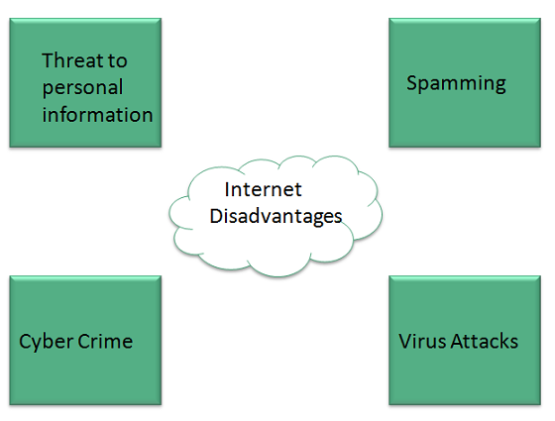

* There are always chances to loose personal information such as name, address, credit card number. Therefore, one should be very careful while sharing such information. One should use credit cards only through authenticated sites.
* Another disadvantage is the **Spamming**. Spamming corresponds to the unwanted e-mails in bulk. These e-mails serve no purpose and lead to obstruction of entire system.
* **Virus** can easily be spread to the computers connected to internet. Such virus attacks may cause your system to crash or your important data may get deleted.
* Also a biggest threat on internet is pornography. There are many pornographic sites that can be found, letting your children to use internet which indirectly affects the children healthy mental life.
* There are various websites that do not provide the authenticated information. This leads to misconception among many people.

## Intranet

Intranet is defined as private network of computers within an organization with its own server and firewall. Moreover, we can define Intranet as:

* Intranet is system in which multiple PCs are networked to be connected to each other. PCs in intranet are not available to the world outside of the intranet.
* Usually each company or organization has their own Intranet network and members/employees of that company can access the computers in their intranet.
* Every computer in internet is identified by a unique IP address.
* Each computer in Intranet is also identified by a IP Address, which is unique among the computers in that Intranet.

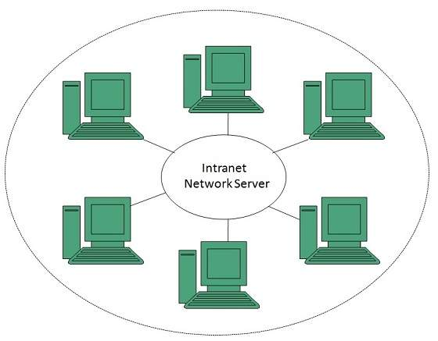

## Benefits

Intranet is very efficient and reliable network system for any organization. It is beneficial in every aspect such as collaboration, cost-effectiveness, security, productivity and much more.

### **Communication**

Intranet offers easy and cheap communication within an organization. Employees can communicate using chat, e-mail or blogs.

### **Time Saving**

Information on Intranet is shared in real time.

### **Collaboration**

Information is distributed among the employees as according to requirement and it can be accessed by the authorized users, resulting in enhanced teamwork.

### **Platform Independency**

Intranet can connect computers and other devices with different architecture.

### **Cost Effective**

Employees can see the data and other documents using browser rather than printing them and distributing duplicate copies among the employees, which certainly decreases the cost.

### **Workforce Productivity**

Data is available at every time and can be accessed using company workstation. This helps the employees work faster.

### **Business Management**

It is also possible to deploy applications that support business operations.

### **Security**

Since information shared on intranet can only be accessed within an organization, therefore there is almost no chance of being theft.

### **Specific Users**

Intranet targets only specific users within an organization therefore, once can exactly know whom he is interacting.

### **Immediate Updates**

Any changes made to information are reflected immediately to all the users.

## Issues

Apart from several benefits of Intranet, there also exist some issues. These issues are shown in the following diagram:

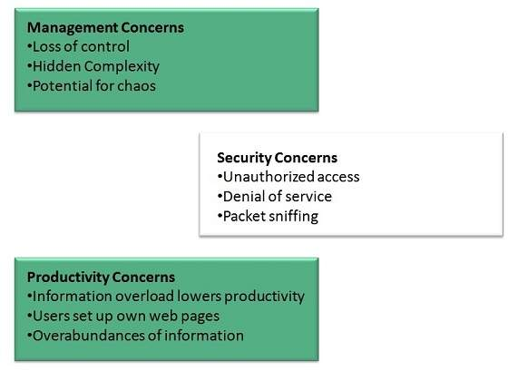

## Applications

Intranet applications are same as that of Internet applications. Intranet applications are also accessed through a web browser. The only difference is that, Intranet applications reside on local server while Internet applications reside on remote server. Here, we've discussed some of these applications:

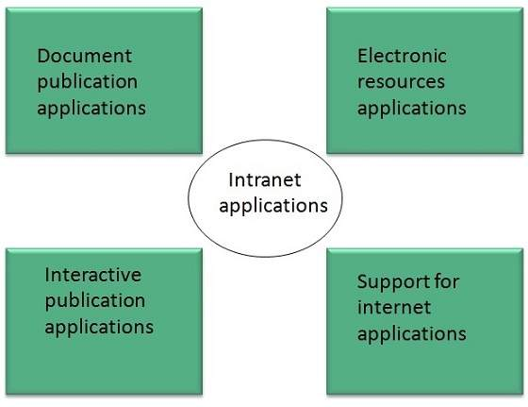

### **Document publication applications**

Document publication applications allow publishing documents such as manuals, software guide, employee profits etc without use of paper.

### **Electronic resources applications**

It offers electronic resources such as software applications, templates and tools, to be shared across the network.

### **Interactive Communication applications**

Like on internet, we have e-mail and chat like applications for Intranet, hence offering an interactive communication among employees.

### **Support for Internet Applications**

Intranet offers an environment to deploy and test applications before placing them on Internet.

## Internet vs. Intranet

Apart from similarities there are some differences between the two. Following are the differences between Internet and Intranet:

|  |  |
| --- | --- |
| **Intranet** | **Internet** |
| Localized Network. | Worldwide Network |
| Doesn't have access to Intranet | Have access to Internet. |
| More Expensive | Less Expensive |
| More Safe | Less Safe |
| More Reliability | Less Reliability |

## Extranet vs. Intranet

The following table shows differences between Extranet and Intranet:

|  |  |
| --- | --- |
| **Extranet** | **Intranet** |
| Internal network that can be accessed externally. | Internal network that cannot be accessed externally. |
| Extranet is extension of company's Intranet. | Only limited users of a company. |
| For limited external communication between customers, suppliers and business partners. | Only for communication within a company. |

## Extranet

Extranet refers to network within an organization, using internet to connect to the outsiders in controlled manner. It helps to connect businesses with their customers and suppliers and therefore allows working in a collaborative manner.

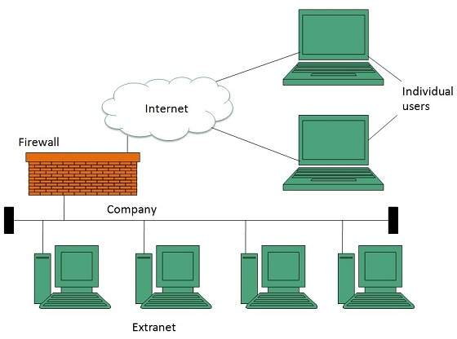

### **Implementation**

Extranet is implemented as a Virtual Private Networks (VPN) because it uses internet to connect to corporate organization and there is always a threat to information security. VPN offers a secure network in public infrastructure (Internet).

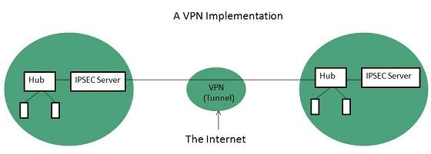

**Key Points**

* The packet is encapsulated at boundary of networks in IPSEC complaint routers.
* It uses an encryption key to encapsulate packets and IP addresses as well.
* The packet is decoded only by the IPSEC complaint routers or servers.
* The message is sent over VPN via VPN Tunnel and this process is known as tunneling.

VPN uses **Internet Protocol Security Architecture (IPSEC)** Protocol to provide secure transactions by adding an additional security layer to TCP/IP protocol. This layer is created by encapsulating the IP packet to a new IP packet as shown in the following diagram:

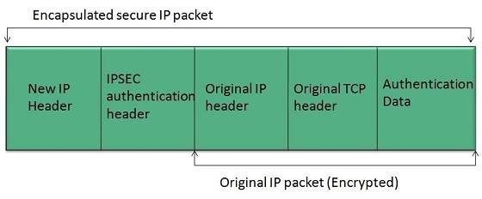

## Benefits

Extranet proves to be a successful model for all kind of businesses whether small or big. Here are some of the advantages of extranet for employees, suppliers, business partners, and customers:

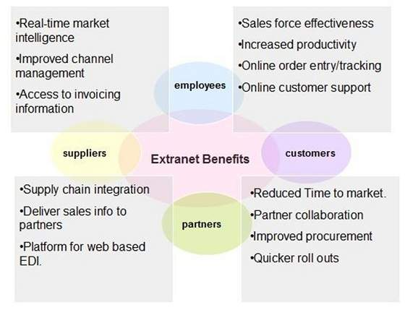

## Issues

Apart for advantages there are also some issues associated with extranet. These issues are discussed below:

### **Hosting**

Where the extranet pages will be held i.e. who will host the extranet pages. In this context there are two choices:

* Host it on your own server.
* Host it with an Internet Service Provider (ISP) in the same way as web pages.

But hosting extranet pages on your own server requires high bandwidth internet connection which is very costly.

### **Security**

Additional firewall security is required if you host extranet pages on your own server which result in a complex security mechanism and increase work load.

### **Accessing Issues**

Information cannot be accessed without internet connection. However, information can be accessed in Intranet without internet connection.

### **Decreased Interaction**

It decreases the face to face interaction in the business which results in lack of communication among customers, business partners and suppliers.

## Reference Model

Reference Model offers a means of standardization which is acceptable worldwide. Since people using the computer network are located over a wide physical range and their network devices might have heterogeneous architecture. In order to provide communication among heterogeneous devices, we need a standardized model i.e. a reference model, which would provide us way how these devices can communicate regardless their architecture.

We have two reference models such as **OSI** model and **TCP/IP** reference model, however, the OSI model is a hypothetical one but the TCP/IP is absolutely practical model.

## OSI Model

**OSI** is acronym of **Open System Interface**. This model is developed by the **International organization of Standardization (ISO)** and therefore also referred as **ISO-OSI** Model.

The OSI model consists of seven layers as shown in the following diagram. Each layer has a specific function, however each layer provide services to the layer above.

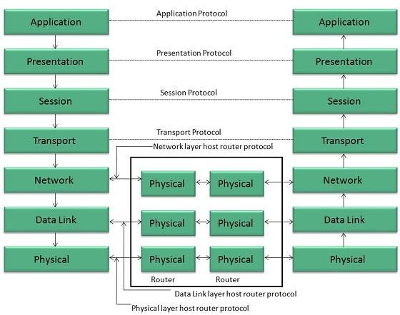

### **Physical Layer**

The Physical layer is responsible for the following activities:

* Activating, maintaining and deactivating the physical connection.
* Defining voltages and data rates needed for transmission.
* Converting digital bits into electrical signal.
* Deciding whether the connection is simplex, half duplex or full duplex.

### **Data Link Layer**

The data link layer performs the following functions:

* Performs synchronization and error control for the information which is to be transmitted over the physical link.
* Enables error detection, and adds error detection bits to the data which are to be transmitted.

### **Network Layer**

Following are the functions of Network Layer:

* To route the signals through various channels to the other end.
* To act as the network controller by deciding which route data should take.
* To divide the outgoing messages into packets and to assemble incoming packets into messages for higher levels.

### **Transport Layer**

The Transport layer performs the following functions:

* It decides if the data transmission should take place on parallel paths or single path.
* It performs multiplexing, splitting on the data.
* It breaks the data groups into smaller units so that they are handled more efficiently by the network layer.

The Transport Layer guarantees transmission of data from one end to other end.

### **Session Layer**

The Session layer performs the following functions:

* Manages the messages and synchronizes conversations between two different applications.
* It controls logging on and off, user identification, billing and session management.

### **Presentation Layer**

The Presentation layer performs the following functions:

<="" ul="" style="box-sizing: border-box; color: rgb(49, 49, 49); font-family: Verdana, Geneva, Tahoma, Arial, Helvetica, sans-serif; font-size: 14px; font-style: normal; font-variant-ligatures: normal; font-variant-caps: normal; font-weight: normal; letter-spacing: normal; orphans: 2; text-align: start; text-indent: 0px; text-transform: none; white-space: normal; widows: 2; word-spacing: 0px; -webkit-text-stroke-width: 0px;">

* This layer makes it sure that the information is delivered in such a form that the receiving system will understand and use it.

### **Application Layer**

The Application layer performs the following functions:

* It provides different services such as manipulation of information in several ways, retransferring the files of information, distributing the results etc.
* The functions such as LOGIN or password checking are also performed by the application layer.

## TCP/IP Model

**TCP/IP** model is practical model and is used in the Internet. TCP/IP is acronym of Transmission Control Protocol and Internet Protocol.

The **TCP/IP** model combines the two layers (Physical and Data link layer) into one layer i.e. **Host-to-Network** layer. The following diagram shows the various layers of TCP/IP model:

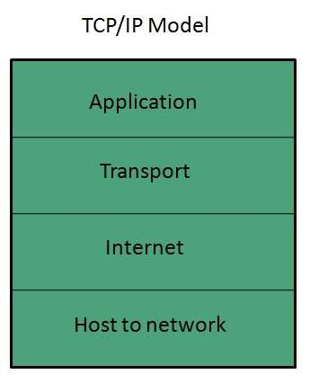

### **Application Layer**

This layer is same as that of the OSI model and performs the following functions:

* It provides different services such as manipulation of information in several ways, retransferring the files of information, distributing the results etc.
* The functions such as LOGIN or password checking are also performed by the application layer.

**Protocols used: TELNET, FTP, SMTP, DN, HTTP, NNTP** are the protocols employed in this layer.

### **Transport Layer**

It does the same functions as that of transport layer in OSI model. Here are the key points regarding transport layer:

* It uses **TCP** and **UDP** protocol for end to end transmission.
* TCP is reliable and **connection oriented protocol.**
* TCP also handles flow control.
* The UDP is not reliable and a **connection less protocol** also does not perform flow control.

**Protocols used: TCP/IP** and **UDP** protocols are employed in this layer.

### **Internet Layer**

The function of this layer is to allow the host to insert packets into network and then make them travel independently to the destination. However, the order of receiving the packet can be different from the sequence they were sent.

**Protocols used: Internet Protocol (IP)** is employed in Internet layer.

### **Host-to-Network Layer**

This is the lowest layer in TCP/IP model. The host has to connect to network using some protocol, so that it can send IP packets over it. This protocol varies from host to host and network to network.

**Protocols used: ARPANET, SATNET, LAN, packet radio** are the protocols which are used in this layer.

# **Internet Domain Name System**

## Overview

When **DNS** was not into existence, one had to download a **Host file** containing host names and their corresponding IP address. But with increase in number of hosts of internet, the size of host file also increased. This resulted in increased traffic on downloading this file. To solve this problem the DNS system was introduced.

**Domain Name System** helps to resolve the host name to an address. It uses a hierarchical naming scheme and distributed database of IP addresses and associated names

## IP Address

IP address is a unique logical address assigned to a machine over the network. An IP address exhibits the following properties:

* IP address is the unique address assigned to each host present on Internet.
* IP address is 32 bits (4 bytes) long.
* IP address consists of two components:**network component** and **host component**.
* Each of the 4 bytes is represented by a number from 0 to 255, separated with dots. For example 137.170.4.124

IP address is 32-bit number while on the other hand domain names are easy to remember names. For example, when we enter an email address we always enter a symbolic string such as webmaster@tutorialspoint.com.

## Uniform Resource Locator (URL)

**Uniform Resource Locator (URL)** refers to a web address which uniquely identifies a document over the internet.

This document can be a web page, image, audio, video or anything else present on the web.

For example, **www.tutorialspoint.com/internet\_technology/index.html** is an URL to the index.html which is stored on tutorialspoint web server under internet\_technology directory.

### **URL Types**

There are two forms of URL as listed below:

1. Absolute URL
2. Relative URL

#### ABSOLUTE URL

Absolute URL is a complete address of a resource on the web. This completed address comprises of protocol used, server name, path name and file name.

For example http:// www.tutorialspoint.com / internet\_technology /index.htm. where:

* **http** is the protocol.
* **tutorialspoint.com** is the server name.
* **index.htm** is the file name.

The protocol part tells the web browser how to handle the file. Similarly we have some other protocols also that can be used to create URL are:

* FTP
* https
* Gopher
* mailto
* news

#### RELATIVE URL

Relative URL is a partial address of a webpage. Unlike absolute URL, the protocol and server part are omitted from relative URL.

Relative URLs are used for internal links i.e. to create links to file that are part of same website as the WebPages on which you are placing the link.

For example, to link an image on tutorialspoint.com/internet\_technology/internet\_referemce\_models, we can use the relative URL which can take the form like **/internet\_technologies/internet-osi\_model.jpg.**

### **Difference between Absolute and Relative URL**

|  |  |
| --- | --- |
| **Absolute URL** | **Relative URL** |
| Used to link web pages on different websites | Used to link web pages within the same website. |
| Difficult to manage. | Easy to Manage |
| Changes when the server name or directory name changes | Remains same even of we change the server name or directory name. |
| Take time to access | Comparatively faster to access. |

## Domain Name System Architecture

The Domain name system comprises of **Domain Names, Domain Name Space, Name Server** that have been described below:

### **Domain Names**

Domain Name is a symbolic string associated with an IP address. There are several domain names available; some of them are generic such as **com, edu, gov, net** etc, while some country level domain names such as **au, in, za, us** etc.

The following table shows the **Generic** Top-Level Domain names:

|  |
| --- |
|  |
| **Domain Name** | **Meaning** |
| Com | Commercial business |
| Edu | Education |
| Gov | U.S. government agency |
| Int | International entity |
| Mil | U.S. military |
| Net | Networking organization |
| Org | Non profit organization |

The following table shows the **Country top-level** domain names:

|  |
| --- |
|  |
| **Domain Name** | **Meaning** |
| au | Australia |
| in | India |
| cl | Chile |
| fr | France |
| us | United States |
| za | South Africa |
| uk | United Kingdom |
| jp | Japan |
| es | Spain |
| de | Germany |
| ca | Canada |
| ee | Estonia |
| hk | Hong Kong |

### **Domain Name Space**

The domain name space refers a hierarchy in the internet naming structure. This hierarchy has multiple levels (from 0 to 127), with a root at the top. The following diagram shows the domain name space hierarchy:

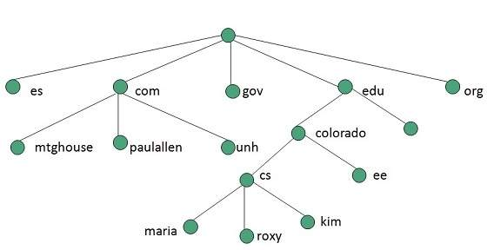

In the above diagram each subtree represents a domain. Each domain can be partitioned into sub domains and these can be further partitioned and so on.

### **Name Server**

Name server contains the DNS database. This database comprises of various names and their corresponding IP addresses. Since it is not possible for a single server to maintain entire DNS database, therefore, the information is distributed among many DNS servers.

* Hierarchy of server is same as hierarchy of names.
* The entire name space is divided into the zones

### **Zones**

Zone is collection of nodes (sub domains) under the main domain. The server maintains a database called zone file for every zone.

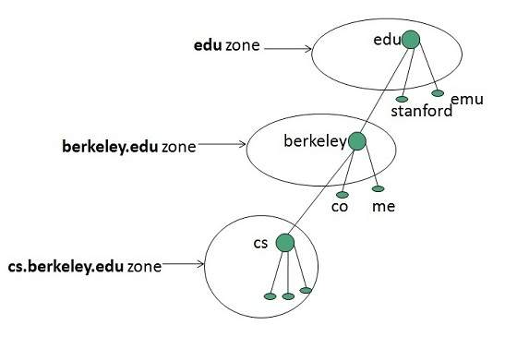

If the domain is not further divided into sub domains then domain and zone refers to the same thing.

The information about the nodes in the sub domain is stored in the servers at the lower levels however; the original server keeps reference to these lower levels of servers.

#### TYPES OF NAME SERVERS

Following are the three categories of Name Servers that manages the entire Domain Name System:

1. Root Server
2. Primary Server
3. Secondary Server

##### ROOT SERVER

Root Server is the top level server which consists of the entire DNS tree. It does not contain the information about domains but delegates the authority to the other server

##### PRIMARY SERVERS

Primary Server stores a file about its zone. It has authority to create, maintain, and update the zone file.

##### SECONDARY SERVER

Secondary Server transfers complete information about a zone from another server which may be primary or secondary server. The secondary server does not have authority to create or update a zone file.

## DNS Working

DNS translates the domain name into IP address automatically. Following steps will take you through the steps included in domain resolution process:

* When we type **www.tutorialspoint.com** into the browser, it asks the local DNS Server for its IP address.

Here the local DNS is at ISP end.

* When the local DNS does not find the IP address of requested domain name, it forwards the request to the root DNS server and again enquires about IP address of it.
* The root DNS server replies with delegation that **I do not know the IP address of www.tutorialspoint.com but know the IP address of DNS Server.**
* The local DNS server then asks the com DNS Server the same question.
* The **com** DNS Server replies the same that it does not know the IP address of www.tutorialspont.com but knows the address of tutorialspoint.com.
* Then the local DNS asks the tutorialspoint.com DNS server the same question.
* Then tutorialspoint.com DNS server replies with IP address of www.tutorialspoint.com.
* Now, the local DNS sends the IP address of www.tutorialspoint.com to the computer that sends the request.

# **Internet Services**

**Internet Services** allows us to access huge amount of information such as text, graphics, sound and software over the internet. Following diagram shows the four different categories of Internet Services.

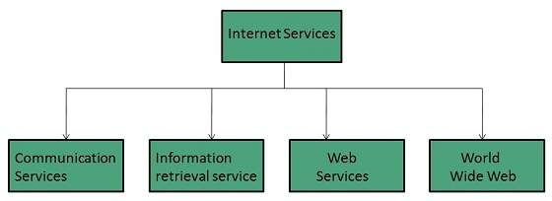

## Communication Services

There are various Communication Services available that offer exchange of information with individuals or groups. The following table gives a brief introduction to these services:

|  |  |
| --- | --- |
| **S.N.** | **Service Description** |
| 1 | **Electronic Mail** Used to send electronic message over the internet. |
| 2 | **Telnet** Used to log on to a remote computer that is attached to internet. |
| 3 | **Newsgroup** Offers a forum for people to discuss topics of common interests. |
| 4 | **Internet Relay Chat (IRC)** Allows the people from all over the world to communicate in real time. |
| 5 | **Mailing Lists** Used to organize group of internet users to share common information through e-mail. |
| 6 | **Internet Telephony (VoIP)** Allows the internet users to talk across internet to any PC equipped to receive the call. |
| 7 | **Instant Messaging** Offers real time chat between individuals and group of people. Eg. Yahoo messenger, MSN messenger. |

## Information Retrieval Services

There exist several Information retrieval services offering easy access to information present on the internet. The following table gives a brief introduction to these services:

|  |  |
| --- | --- |
| **S.N.** | **Service Description** |
| 1 | **File Transfer Protocol (FTP)** Enable the users to transfer files. |
| 2 | **Archie** It’s updated database of public FTP sites and their content. It helps to search a file by its name. |
| 3 | **Gopher** Used to search, retrieve, and display documents on remote sites. |
| 4 | **Very Easy Rodent Oriented Netwide Index to Computer Achieved (VERONICA)**  VERONICA is gopher based resource. It allows access to the information resource stored on gopher’s servers. |

## Web Services

Web services allow exchange of information between applications on the web. Using web services, applications can easily interact with each other.

The web services are offered using concept of **Utility Computing.**

## World Wide Web (WWW)

WWW is also known as W3. It offers a way to access documents spread over the several servers over the internet. These documents may contain texts, graphics, audio, video, hyperlinks. The hyperlinks allow the users to navigate between the documents.

## Video Conferencing

Video conferencing or Video teleconferencing is a method of communicating by two-way video and audio transmission with help of telecommunication technologies.

### **Modes of Video Conferencing**

#### POINT-TO-POINT

This mode of conferencing connects two locations only.



#### MULTI-POINT

This mode of conferencing connects more than two locations through **Multi-point Control Unit (MCU).**

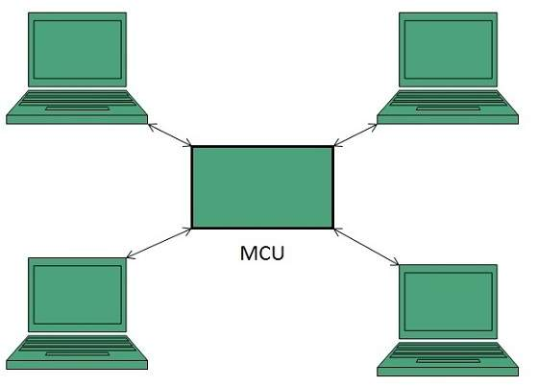

# **Internet Connectivity**

Here in this tutorial, we will discuss how to connect to internet i.e. internet service providers, software and hardware requirements, configuring internet connection etc.

## Internet Service Providers (ISP)

**Internet Service Provider (ISP)** is a company offering access to internet. They offer various services:

* Internet Access
* Domain name registration
* Dial-up access
* Leased line access

### **ISP Types**

ISPs can broadly be classified into six categories as shown in the following diagram:

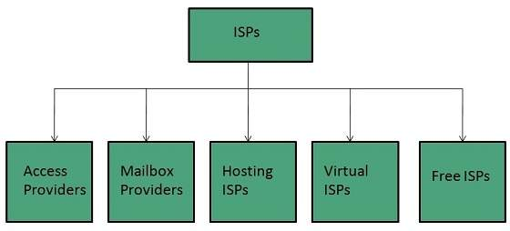

#### ACCESS PROVIDERS

They provide access to internet through telephone lines, cable wi-fi or fiber optics.

#### MAILBOX PROVIDER

Such providers offer mailbox hosting services.

#### HOSTING ISPS

Hosting ISPs offers e-mail, and other web hosting services such as virtual machines, clouds etc.

#### VIRTUAL ISPS

Such ISPs offer internet access via other ISP services.

#### FREE ISPS

Free ISPs do not charge for internet services.

## Connection Types

There exist several ways to connect to the internet. Following are these connection types available:

1. Dial-up Connection
2. ISDN
3. DSL
4. Cable TV Internet connections
5. Satellite Internet connections
6. Wireless Internet Connections

### **Dial-up Connection**

**Dial-up** connection uses telephone line to connect PC to the internet. It requires a modem to setup dial-up connection. This modem works as an interface between PC and the telephone line.

There is also a communication program that instructs the modem to make a call to specific number provided by an ISP.

Dial-up connection uses either of the following protocols:

1. Serial Line Internet Protocol (SLIP)
2. Point to Point Protocol (PPP)

The following diagram shows the accessing internet using modem:

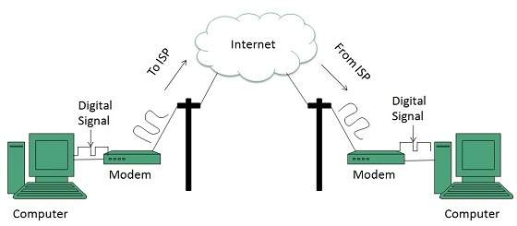

### **ISDN**

**ISDN** is acronym of **Integrated Services Digital Network.** It establishes the connection using the phone lines which carry digital signals instead of analog signals.

There are two techniques to deliver ISDN services:

1. Basic Rate Interface (BRI)
2. Primary Rate Interface (PRI)

**Key points:**

* The BRI ISDN consists of three distinct channels on a single ISDN line: t1o 64kbps B (Bearer) channel and one 16kbps D (Delta or Data) channels.
* The PRI ISDN consists of 23 B channels and one D channels with both have operating capacity of 64kbps individually making a total transmission rate of 1.54Mbps.

The following diagram shows accessing internet using ISDN connection:

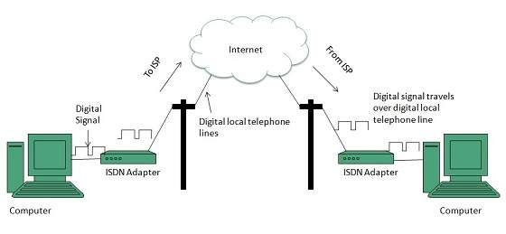

### **DSL**

**DSL** is acronym of **Digital Subscriber Line.** It is a form of broadband connection as it provides connection over ordinary telephone lines.

Following are the several versions of DSL technique available today:

1. Asymmetric DSL (ADSL)
2. Symmetric DSL (SDSL)
3. High bit-rate DSL (HDSL)
4. Rate adaptive DSL (RDSL)
5. Very high bit-rate DSL (VDSL)
6. ISDN DSL (IDSL)

All of the above mentioned technologies differ in their upload and download speed, bit transfer rate and level of service.

The following diagram shows that how we can connect to internet using DSL technology:

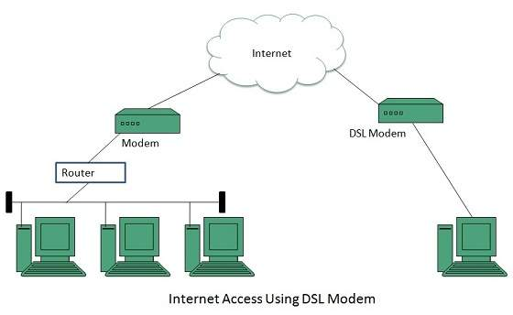

### **Cable TV Internet Connection**

Cable TV Internet connection is provided through Cable TV lines. It uses coaxial cable which is capable of transferring data at much higher speed than common telephone line.

**Key Points:**

* A cable modem is used to access this service, provided by the cable operator.
* The Cable modem comprises of two connections: one for internet service and other for Cable TV signals.
* Since Cable TV internet connections share a set amount of bandwidth with a group of customers, therefore, data transfer rate also depends on number of customers using the internet at the same time.

The following diagram shows that how internet is accessed using Cable TV connection:

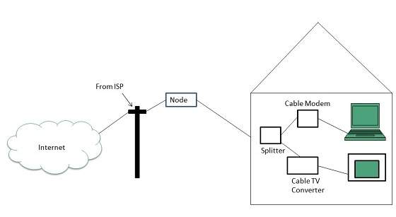

### **Satellite Internet Connection**

Satellite Internet connection offers high speed connection to the internet. There are two types of satellite internet connection: one way connection or two way connection.

In one way connection, we can only download data but if we want to upload, we need a dialup access through ISP over telephone line.

In two way connection, we can download and upload the data by the satellite. It does not require any dialup connection.

The following diagram shows how internet is accessed using satellite internet connection:

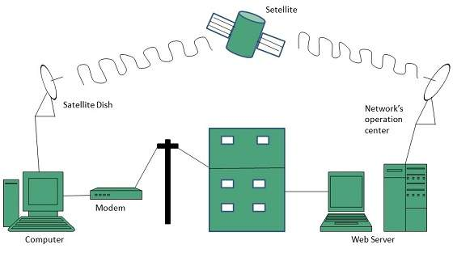

### **Wireless Internet Connection**

Wireless Internet Connection makes use of radio frequency bands to connect to the internet and offers a very high speed. The wireless internet connection can be obtained by either WiFi or Bluetooth.

**Key Points:**

* Wi Fi wireless technology is based on IEEE 802.11 standards which allow the electronic device to connect to the internet.
* Bluetooth wireless technology makes use of short-wavelength radio waves and helps to create personal area network (PAN).

# **Internet Protocols**

## Transmission Control Protocol (TCP)

TCP is a connection oriented protocol and offers end-to-end packet delivery. It acts as back bone for connection.It exhibits the following key features:

* Transmission Control Protocol (TCP) corresponds to the Transport Layer of OSI Model.
* TCP is a reliable and connection oriented protocol.
* TCP offers:
  + Stream Data Transfer.
  + Reliability.
  + Efficient Flow Control
  + Full-duplex operation.
  + Multiplexing.
* TCP offers connection oriented end-to-end packet delivery.
* TCP ensures reliability by sequencing bytes with a forwarding acknowledgement number that indicates to the destination the next byte the source expect to receive.
* It retransmits the bytes not acknowledged with in specified time period.

### **TCP Services**

TCP offers following services to the processes at the application layer:

* Stream Delivery Service
* Sending and Receiving Buffers
* Bytes and Segments
* Full Duplex Service
* Connection Oriented Service
* Reliable Service

#### STREAM DELIVER SERVICE

TCP protocol is stream oriented because it allows the sending process to send data as stream of bytes and the receiving process to obtain data as stream of bytes.

#### SENDING AND RECEIVING BUFFERS

It may not be possible for sending and receiving process to produce and obtain data at same speed, therefore, TCP needs buffers for storage at sending and receiving ends.

#### BYTES AND SEGMENTS

The Transmission Control Protocol (TCP), at transport layer groups the bytes into a packet. This packet is called segment. Before transmission of these packets, these segments are encapsulated into an IP datagram.

#### FULL DUPLEX SERVICE

Transmitting the data in duplex mode means flow of data in both the directions at the same time.

#### CONNECTION ORIENTED SERVICE

TCP offers connection oriented service in the following manner:

1. TCP of process-1 informs TCP of process – 2 and gets its approval.
2. TCP of process – 1 and TCP of process – 2 and exchange data in both the two directions.
3. After completing the data exchange, when buffers on both sides are empty, the two TCP’s destroy their buffers.

#### RELIABLE SERVICE

For sake of reliability, TCP uses acknowledgement mechanism.

## Internet Protocol (IP)

Internet Protocol is **connectionless** and **unreliable** protocol. It ensures no guarantee of successfully transmission of data.

In order to make it reliable, it must be paired with reliable protocol such as TCP at the transport layer.

Internet protocol transmits the data in form of a datagram as shown in the following diagram:

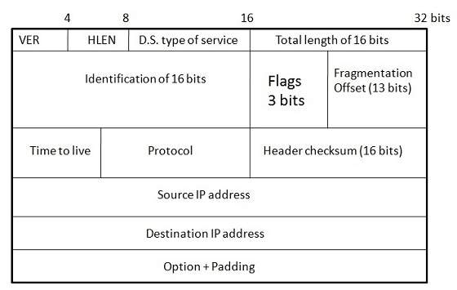

**Points to remember:**

* The length of datagram is variable.
* The Datagram is divided into two parts: **header** and **data.**
* The length of header is 20 to 60 bytes.
* The header contains information for routing and delivery of the packet.

## User Datagram Protocol (UDP)

Like IP, UDP is connectionless and unreliable protocol. It doesn’t require making a connection with the host to exchange data. Since UDP is unreliable protocol, there is no mechanism for ensuring that data sent is received.

UDP transmits the data in form of a datagram. The UDP datagram consists of five parts as shown in the following diagram:

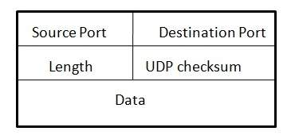

**Points to remember:**

* UDP is used by the application that typically transmit small amount of data at one time.
* UDP provides protocol port used i.e. UDP message contains both source and destination port number, that makes it possible for UDP software at the destination to deliver the message to correct application program.

## File Transfer Protocol (FTP)

FTP is used to copy files from one host to another. FTP offers the mechanism for the same in following manner:

* FTP creates two processes such as Control Process and Data Transfer Process at both ends i.e. at client as well as at server.
* FTP establishes two different connections: one is for data transfer and other is for control information.
* **Control connection** is made between **control processes** while **Data Connection** is made between<="" b="" style="box-sizing: border-box;">
* FTP uses **port 21** for the control connection and **Port 20** for the data connection.

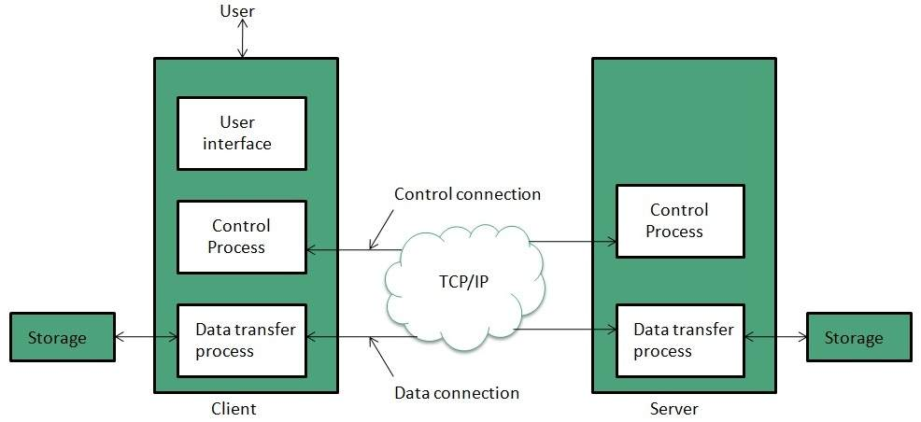

## Trivial File Transfer Protocol (TFTP)

**Trivial File Transfer Protocol** is also used to transfer the files but it transfers the files without authentication. Unlike FTP, TFTP does not separate control and data information. Since there is no authentication exists, TFTP lacks in security features therefore it is not recommended to use TFTP.

**Key points**

* TFTP makes use of UDP for data transport. Each TFTP message is carried in separate UDP datagram.
* The first two bytes of a TFTP message specify the type of message.
* The TFTP session is initiated when a TFTP client sends a request to upload or download a file.
* The request is sent from an ephemeral UDP port to the **UDP port 69**of an TFTP server.

## Difference between FTP and TFTP

|  |  |  |  |
| --- | --- | --- | --- |
| **S.N.** | **Parameter** | **FTP** | **TFTP** |
| 1 | Operation | Transferring Files | Transferring Files |
| 2 | Authentication | Yes | No |
| 3 | Protocol | TCP | UDP |
| 4 | Ports | 21 – Control, 20 – Data | Port 3214, 69, 4012 |
| 5 | Control and Data | Separated | Separated |
| 6 | Data Transfer | Reliable | Unreliable |

## Telnet

Telnet is a protocol used to log in to remote computer on the internet. There are a number of Telnet clients having user friendly user interface. The following diagram shows a person is logged in to computer A, and from there, he remote logged into computer B.

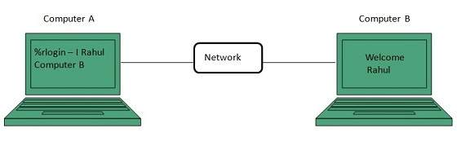

## Hyper Text Transfer Protocol (HTTP)

HTTP is a communication protocol. It defines mechanism for communication between browser and the web server. It is also called request and response protocol because the communication between browser and server takes place in request and response pairs.

### **HTTP Request**

HTTP request comprises of lines which contains:

* Request line
* Header Fields
* Message body

**Key Points**

* The first line i.e. the **Request line** specifies the request method i.e. **Get** or **Post.**
* The second line specifies the header which indicates the domain name of the server from where index.htm is retrieved.

### **HTTP Response**

Like HTTP request, HTTP response also has certain structure. HTTP response contains:

* Status line
* Headers
* Message body

**Internet Basics**

**Internet Overview:-**

a global computer network providing a variety of information and communication facilities, consisting of interconnected networks using standardized communication protocols.

**Intranet Overview:-**

An **intranet** is a private network accessible only to an organization's staff. Generally a wide range of information and services from the organization's internal IT systems are available that would not be available to the public from the Internet.

**Extranet Overview:**

an intranet that can be partially accessed by authorized outside users, enabling businesses to exchange information over the Internet in a secure way.

Internet reference Models

**Internet Domain Name System:-**

naming **system** for computers, services, or any resource connected to the **Internet** or a private network. It associates various information with **domain names** assigned to each of the participating entities.

**IPv4:-**

IP address is 32 bits (4 bytes) long.

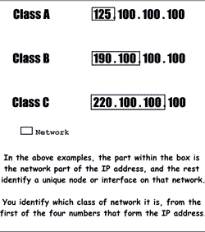

IP Address Masking

•**Class A-** 1.0.0.0 to 126.0.0.0,   255.0.0.0

•**Class B-** 128.0.0.0 to 191.0.0.0 255.255.0.0

•**Class C-** 192.0.0.0 to 223.0.0.0 255.255.255.0

•**Class D & E- Reserve for experiment purpose**

Internet Services:-



Internet Connectivity:-

### **ISP Types-**

#### **MAILBOX PROVIDER**

Such providers offer mailbox hosting services.

#### **HOSTING ISPS**

Hosting ISPs offers e-mail, and other web hosting services such as virtual machines, clouds etc.

#### **VIRTUAL ISPS**

Such ISPs offer internet access via other ISP services.

#### **FREE ISPS**

Free ISPs do not charge for internet services.

## Connection Types-

1. **Dial-up Connection**:- Serial line Internet protocal(SLIP)

Point to point Protocal(PPP)

1. **ISDN:-ISDN** is acronym of **Integrated Services Digital Network.** It establishes the connection using the phone lines which carry digital signals instead of analog signals.

There are two techniques to deliver ISDN services:

* 1. Basic Rate Interface (BRI)
  2. Primary Rate Interface (PRI)

1. **DSL**:-**DSL** is acronym of **Digital Subscriber Line.** It is a form of broadband connection as it provides connection over ordinary telephone lines.

Following are the several versions of DSL technique available today:

1. Asymmetric DSL (ADSL)
2. Symmetric DSL (SDSL)
3. High bit-rate DSL (HDSL)
4. Rate adaptive DSL (RDSL)
5. Very high bit-rate DSL (VDSL)
6. ISDN DSL (IDSL)
7. Cable TV Internet connections:-

Cable TV Internet connection is provided through Cable TV lines. It uses coaxial cable which is capable of transferring data at much higher speed than common telephone line.

1. Satellite Internet connections:-

* In one way connection, we can only download data but if we want to upload, we need a dialup access through ISP over telephone line.
* In two way connection, we can download and upload the data by the satellite. It does not require any dialup connection.

1. Wireless Internet Connections:-

Wireless Internet Connection makes use of radio frequency bands to connect to the internet and offers a very high speed. The wireless internet connection can be obtained by either WiFi or Bluetooth.

***Internet Protocols:-***

## User Datagram Protocol (UDP)

## File Transfer Protocol (FTP)

## Trivial File Transfer Protocol (TFTP)

## Telnet

## Hyper Text Transfer Protocol (HTTP)

**Electronic Mail Basics**

E-Mail Overview:-

Email is a service which allows us to send the message in electronic mode over the internet.

### **E-mail Header**

The first five lines of an E-mail message is called E-mail header. The header part comprises of following fields:

* From
* Date
* To
* Subject
* CC
* BCC

**E-Mail Protocols:-:-**

## 1.SMPTP:- Simple Mail Transfer Protocol. It was first proposed in 1982. It is a standard protocol used for sending e-mail efficiently and reliably over the internet.

**Key Points:**

* SMTP is application level protocol.
* SMTP is connection oriented protocol.
* SMTP is text based protocol.
* It handles exchange of messages between e-mail servers over TCP/IP network.

## 2.IMAP:-IMAP stands for Internet Mail Access Protocol. It was first proposed in 1986. There exist five versions of IMAP as follows:

1. Original IMAP
2. IMAP2
3. IMAP3
4. IMAP2bis
5. IMAP4

**Key Points:**

* IMAP allows the client program to manipulate the e-mail message on the server without downloading them on the local computer.
* The e-mail is hold and maintained by the remote server.
* It enables us to take any action such as downloading, delete the mail without reading the mail.It enables us to create, manipulate and delete remote message folders called mail boxes.
* IMAP enables the users to search the e-mails.
* It allows concurrent access to multiple mailboxes on multiple mail servers.

## 3.POP:-

POP stands for Post Office Protocol. It is generally used to support a single client. There are several versions of POP but the POP 3 is the current standard.

**Key Points**

* POP is an application layer internet standard protocol.
* Since POP supports offline access to the messages, thus requires less internet usage time.
* POP does not allow search facility.

**E-Mail Working:-**

* Suppose person A wants to send an email message to person B.
* Person A composes the messages using a mailer program i.e. mail client and then select Send option.
* The message is routed to **Simple Mail Transfer Protocol** to person B’s mail server.
* The mail server stores the email message on disk in an area designated for person B.

The disk space area on mail server is called mail spool.

**E-Mail Operations:-**

* Compose
* Read
* Reply
* Forword
* Delete

**E-mail Features:-**

## Attachment

## Address Book

## MIME Types-

## MIME is acronym of Multipurpose Internet Mail Extensions. MIME compliant mailer allows us to send files other than simple text i.e. It allows us to send audio, video, images, document, and pdf files as an attachment to an email.

**E-mail Security:-**

### **Spam**

E-mail spamming is an act of sending **Unsolicited Bulk E-mails (UBI)** which one has not asked for. Email spams are the junk mails sent by commercial companies as an advertisement of their products and services.

### **Virus**

Some emails may incorporate with files containing malicious script which when run on your computer may lead to destroy your important data.

### **Phishing**

Email phishing is an activity of sending emails to a user claiming to be a legitimate enterprise. Its main purpose is to steal sensitive information such as usernames, passwords, and credit card details.

**Website Development**

Websites Overview:-

* Static Website

### Dynamic website:

### **Server-side dynamic web page**

It is created by using server-side scripting. There are server-side scripting parameters that determine how to assemble a new web page which also include setting up of more client-side processing.

### **web page Client side dynamic -** client side scripting such as javascript. And then passed in to Document Object Model (side dynamic web page

It is processed using DOM).

Websites Types:-

* Blogs
* E-commerce

Websites Development

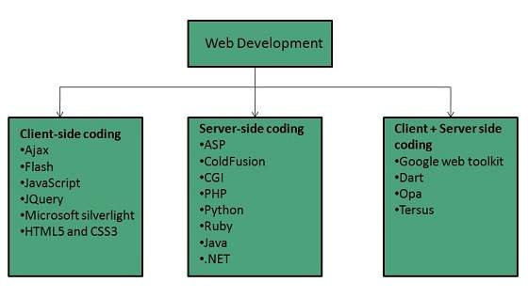

## Web Development Process:-

## internet_technologies_tutorial

Website Hosting:-

|  |  |
| --- | --- |
| **S.N.** | **Hosting Description** |
| 1. | **Shared Hosting** In shared hosting, the hosting company puts thousand of website on the same physical server. Each customer has their own allocation of physical web space and a set of bandwidth limit. As all websites share same physical memory, MYSQL server and Apache server, one website on the server experiencing high traffic load will affect performance of all websites on the server. |
| 2. | **Virtual Private Server (VPS)** It is also known as Virtual Dedicated Server. It is a server which is partitioned into smaller servers. In this customer is given their own partition, which is installed with its own operating system. Unlike shared hosting, VPS doesn’t share memory or processor time rather it allocates certain amount of memory and CPU to use which means that any problem on a VPS partition on the same drive will not affect other VPS customers. |
| 3. | **Dedicated Server** In this kind of hosting, single dedicated server is setup for just one customer. It is commonly used by the businesses that need the power, control and security that a dedicated server offers. |
| 4. | **Reseller Hosting** A reseller acts as a middle man and sells hosting space of someone else’s server. |
| 5. | **Grid Hosting** Instead of utilizing one server, Grid Hosting spreads resources over a large number of servers. It is quite stable and flexible. The servers can be added or taken away from the grid without crashing the system. |

Website Security:-

### **Updated Software**

It is mandatory to keep you software updated. It plays vital role in keeping your website secure.

### **SQL Injection**

It is an attempt by the hackers to manipulate your database. It is easy to insert rogue code into your query that can be used to manipulate your database such as change tables, get information or delete data.

### **Cross Site Scripting (XSS)**

It allows the attackers to inject client side script into web pages. Therefore, while creating a form It is good to endure that you check the data being submitted and encode or strip out any HTML.

### **Error Messages**

You need to be careful about how much information to be given in the error messages. For example, if the user fails to log in the error message should not let the user know which field is incorrect: username or password.

### **Validation of Data**

The validation should be performed on both server side and client side.

### **Passwords**

It is good to enforce password requirements such as of minimum of eight characters, including upper case, lower case and special character. It will help to protect user’s information in long run.

### **Upload files**

The file uploaded by the user may contain a script that when executed on the server opens up your website.

### **SSL**

It is good practice to use SSL protocol while passing personal information between website and web server or database.

**Search Engine Optimization:-Search Engine Optimization** refers to set of activities that are performed to increase number of desirable visitors who come to your site via search engine.

### **Types of SEO:-**

* White Hat SEO (legal)
* Black Hat or Spamdexing(illegal)

**Website Monetization:-**

## Methods of Monetization

### **Display Advertising**

It refers to the banners and text ads. This method is good for the websites that have significant traffic, valuable audience, relevant and active advertisers.

### **Affiliate Marketing**

It refers to steering the visitors to products and services of a third party merchant. It is good for the websites that are product centric and have easy integration into content.

### **Lead generation**

It refers to capturing the customer information and selling it to a third party.

### **Email rental**

It refers to renting out your email lists to third parties. In this you will send an email on their behalf to your distribution list.

**World Wide Web**

WWW Overview:-

**WWW** stands for **World Wide Web.** A technical definition of the World Wide Web is : all the resources and users on the Internet that are using the Hypertext Transfer Protocol (HTTP). **Tim Berners-Lee**

Web Pages:-

* **Static web pages** are also known as flat or stationary web page. They are loaded on the client’s browser as exactly they are stored on the web server. Such web pages contain only static information. User can only read the information but can’t do any modification or interact with the information.

Static web pages are created using only HTML. Static web pages are only used when the information is no more required to be modified.

* **Dynamic web page** shows different information at different point of time. It is possible to change a portaion of a web page without loading the entire web page. It has been made possible using **Ajax** technology.

#### **SERVER-SIDE DYNAMIC WEB PAGE**

It is created by using server-side scripting. There are server-side scripting parameters that determine how to assemble a new web page which also include setting up of more client-side processing.

#### **CLIENT-SIDE DYNAMIC WEB PAGE**

It is processed using client side scripting such as JavaScript. And then passed in to **Document Object Model (DOM).**

## Scripting Laguages:- Scripting language is used to create dynamic web pages.

### Client-side Scripting

### Server-side Scripting

**Web Browser** :-is an application software that allows us to view and explore information on the web. User can request for any web page by just entering a URL into address bar.

Web browser can show text, audio, video, animation and more. It is the responsibility of a web browser to interpret text and commands contained in the web page.

Earlier the web browsers were text-based while now a days graphical-based or voice-based web browsers are also available.

**Web Servers:-** Web site is collection of web pages whileweb server is a software that respond to the request for web resources.

**Web Server Working**

Web server respond to the client request in either of the following two ways:

* Sending the file to the client associated with the requested URL.
* Generating response by invoking a script and communicating with database

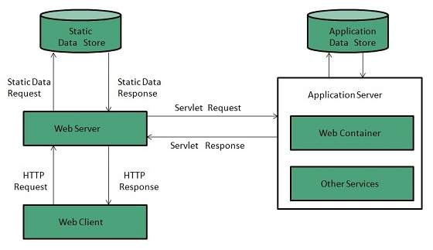

**Key Points**

* When client sends request for a web page, the web server search for the requested page if requested page is found then it will send it to client with an HTTP response.
* If the requested web page is not found, web server will the send an **HTTP response:Error 404 Not found.**
* If client has requested for some other resources then the web server will contact to the application server and data store to construct the HTTP response.

**Proxy server** is an intermediary server between client and the interner. Proxy servers offers the following basic functionalities:

* Firewall and network data filtering.
* Network connection sharing
* Data caching

Proxy servers allow to hide, conceal and make your network id anonymous by hiding your IP address.

**Purpose of Proxy Servers**

Following are the reasons to use proxy servers:

* Monitoring and Filtering
* Improving performance
* Translation
* Accessing services anonymously
* Security

## Type of Proxies

Following table briefly describes the type of proxies:

### **Forward Proxies**

In this the client requests its internal network server to forward to the internet.

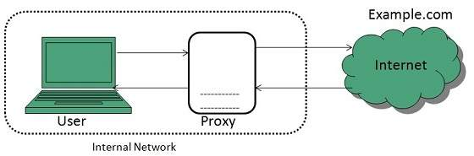

### **Open Proxies**

Open Proxies helps the clients to conceal their IP address while browsing the web.

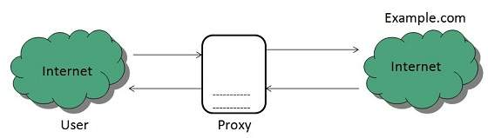

### **Reverse Proxies**

In this the requests are forwarded to one or more proxy servers and the response from the proxy server is retrieved as if it came directly from the original Server.

## Architecture

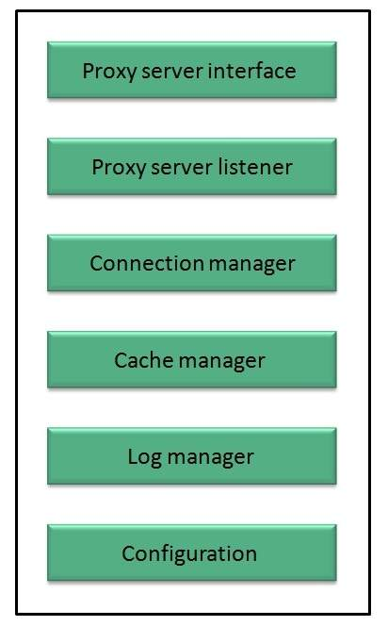

**Search Engines:-**

## Search Engine Components

1. Web Crawler
2. Database
3. Search Interfaces

### **Web crawler**

It is also known as **spider** or **bots.** It is a software component that traverses the web to gather information.

### **Database**

All the information on the web is stored in database. It consists of huge web resources.

### **Search Interfaces**

This component is an interface between user and the database. It helps the user to search through the database.

## Search Engine Working

Web crawler, database and the search interface are the major component of a search engine that actually makes search engine to work. Search engines make use of Boolean expression AND, OR, NOT to restrict and widen the results of a search. Following are the steps that are performed by the search engine:

* The search engine looks for the keyword in the index for predefined database instead of going directly to the web to search for the keyword.
* It then uses software to search for the information in the database. This software component is known as web crawler.
* Once web crawler finds the pages, the search engine then shows the relevant web pages as a result. These retrieved web pages generally include title of page, size of text portion, first several sentences etc.

These search criteria may vary from one search engine to the other. The retrieved information is ranked according to various factors such as frequency of keywords, relevancy of information, links etc.

* User can click on any of the search results to open it.

**Internet Security and Privacy**

**Internet Security Overview:-**

Internet security refers to securing communication over the internet. It includes specific security protocols such as:

* Internet Security Protocol (IPSec)
* Secure Socket Layer (SSL)

### **Internet Security Protocol (IPSec)**

It consists of a set of protocols designed by Internet Engineering Task Force (IETF). It provides security at network level and helps to create authenticated and confidential packets for IP layer.

### **Secure Socket Layer (SSL)**

It is a security protocol developed by Netscape Communications Corporation. ). It provides security at transport layer. It addresses the following security issues:

* Privacy
* Integrity
* Authentication

## Threats

Internet security threats impact the network, data security and other internet connected systems. Cyber criminals have evolved several techniques to threat privacy and integrity of bank accounts, businesses, and organizations.

Following are some of the internet security threats:

* Mobile worms
* Malware
* PC and Mobile ransomware
* Large scale attacks like Stuxnet that attempts to destroy infrastructure.
* Hacking as a Service
* Spam
* Phishing

## Email Phishing

**Email phishing** is an activity of sending emails to a user claiming to be a legitimate enterprise. Its main purpose is to steal sensitive information such as usernames, passwords, and credit card details.

Such emails contains link to websites that are infected with malware and direct the user to enter details at a fake website whose look and feels are same to legitimate one.

**Data Encryption:-**

### **Types of Encryption**

There are two types of encryptions schemes as listed below:

* Symmetric Key encryption
* Public Key encryption

#### SYMMETRIC KEY ENCRYPTION

**Symmetric key encryption** algorithm uses same cryptographic keys for both encryption and decryption of cipher text.

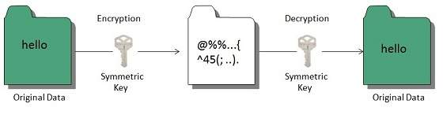

#### PUBLIC KEY ENCRYPTION

**Public key encryption** algorithm uses pair of keys, one of which is a secret key and one of which is public. These two keys are mathematically linked with each other.

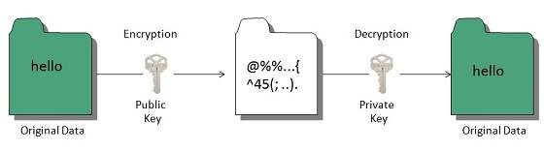

## Hashing

In terms of security, hashing is a technique used to encrypt data and generate unpredictable hash values. It is the hash function that generates the hash code, which helps to protect the security of transmission from unauthorized users.

**Digital signatures** :-allow us to verify the author, date and time of signatures, authenticate the message contents. It also includes authentication function for additional capabilities.

## Applications

There are several reasons to implement digital signatures to communications:

### **Authentication**

Digital signatures help to authenticate the sources of messages. For example, if a bank’s branch office sends a message to central office, requesting for change in balance of an account. If the central office could not authenticate that message is sent from an authorized source, acting of such request could be a grave mistake.

### **Integrity**

Once the message is signed, any change in the message would invalidate the signature.

### **Non-repudiation**

By this property, any entity that has signed some information cannot at a later time deny having signed it.

**Firewall Security: -**

**Firewall** is a barrier between Local Area Network (LAN) and the Internet. It allows keeping private resources confidential and minimizes the security risks. It controls network traffic, in both directions.

There are two types of Firewall system: One works by using filters at the network layer and the other works by using proxy servers at the user, application, or network layer.

**Key Points**

* Firewall management must be addressed by both system managers and the network managers.
* The amount of filtering a firewall varies. For the same firewall, the amount of filtering may be different in different directions.

**Internet Web Programming**

HTML

CSS

JavaScript

PHP